Online Login with multiple codesys versions

Handling the Gateway service

Codesys installs a windows service called the Gateway to communicate to connected devices. When multiple versions of Codesys are installed, the Gateway service is always configured for the latest installed version. This means that when trying to login to a device using any Codesys version other than the latest installed version, Codesys may not be able to use the Gateway properly and thus not connect to the device.

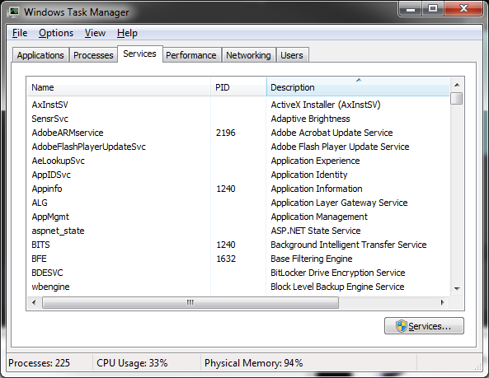
1. Find the Service:
Right click the Windows taskbar and open the Task Manager. Select the Services tab and click the services button at the bottom right:

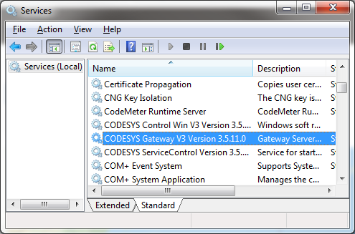
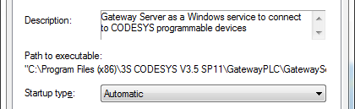
Find the “CODESYS Gateway V3 Version 3.5.x.x”
service. Right click it and select Properties.
The location of the gateway service that is currently being used is in the “Path to executable” line in the General tab.
This path indicates that the gateway service is going to use the gateway and configuration files from the
C:\Program Files (x86)\3S CODESYS V3.5 SP11\GatewayPLC\
directory. This will work as-is for this Codesys v3.5 SP11 installation, but it will most likely not work for any other Codesys v3.5 version. To work across different Codesys installations, the gateway must have access to all the files it needs for the different installations. This means that gateway files for all Codesys installations must be in this directory. But they cannot all be placed there without overwriting each other.
2. Copy GatewayPLC Files:
In order to use the gateway from an earlier installation…
- Rename the GatewayPLC folder in the directory of the newest installation, in this case
C:\Program Files (x86)\3S CODESYS v3.5 SP11, to something like GatewayPLC_SP11. This way it will not be recognized by Codesys and will not be used.

- Now you can simply copy the GatewayPLC folder from the desired installation into this directory, and Codesys will use this for online login.

- When you want to go back to the SP11 gateway (or whichever is the newest installed version), just rename the folders again.
You may need to manually stop and restart the gateway services (see image 2, above) for this change to take effect.
Now Codesys should be able to scan the network and find devices for all versions.

