Installing multiple codesys versions

How to prevent conflicts

Codesys uses the directory “C:/ProgramData/CODESYS” to house important program files. When installing a second (or more) version of Codesys, the installer will put its own version of these files in this directory and possibly overwrite existing files. This can cause problems when trying to use the originally installed version of Codesys.

1. CODESYS folder
The solution is to rename the existing CODESYS folder just prior to installing subsequent Codesys versions. It helps to use the version of the existing software when renaming it, like CODESYS_SP6. This way, when the new installer creates files in the CODESYS directory again, the existing files remain unmodified in the renamed folder.
After installation is complete, rename the new CODESYS folder to something descriptive about this new program version (like CODESYS_SP11). Note that when Codesys is run, it will re-create the CODESYS folder to hold some temporary files. This can be ignored.

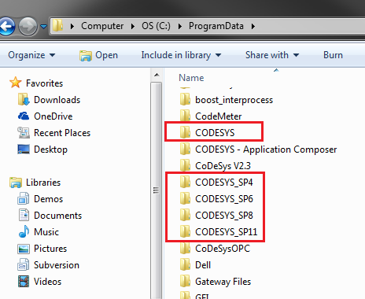

2. RepositoryLocations.ini
The second step is to find the file called…
RepositoryLocations.ini
in the {CoDeSys install folder}\CODESYS\Settings folder for both the original and new versions of Codesys. Modify the directory listings in the files to reflect the changed folder names.
Wachendorff Codesys SP11 installs into C:/Program Files by default, while STW Codesys SP6 installs into C:/Program Files (x86).
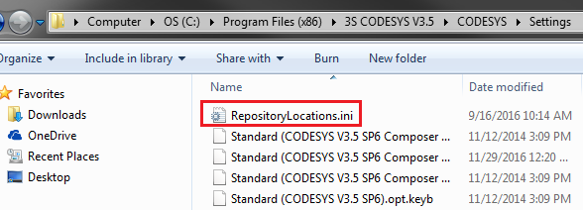
Wachendorff Codesys v3.5 SP11 File Location

EXAMPLE FILE MODIFICATION for SP6:
  - ORIGINAL
Devices=C:\ProgramData\CODESYS\Devices
Managed Libraries=C:\ProgramData\CODESYS\Managed Libraries
…

  - MODIFIED
Devices=C:\ProgramData\CODESYS_SP6\Devices
Managed Libraries=C:\ProgramData\CODESYS_SP6\Managed Libraries
…
EXAMPLE FILE MODIFICATION for SP11:
  - ORIGINAL
Devices=C:\ProgramData\CODESYS\Devices
Managed Libraries=C:\ProgramData\CODESYS\Managed Libraries
…

  - MODIFIED
Devices=C:\ProgramData\CODESYS_SP11\Devices
Managed Libraries=C:\ProgramData\CODESYS_SP11\Managed Libraries
…

