CoDeSys Installation and General Information
CoDeSys is a 3rd party development environment created by the company 3S in Germany. STW has worked closely with 3S to integrate its controller firmware into this environment. When a programmer wants to develop an application on STW controllers with CoDeSys (which employs the coding standard IEC61131-3), several applications must be installed in the developer’s PC. These applications are all in a single install package but you must install each of them separately. Additionally, a CAN dongle must be used to connect the PC’s USB port to the CAN interface on the controller. Some of the applications installed are used to manage that connection. This document walks through the installation process and all the decisions that must be made in that process.
Developing an application for an STW controller and flashing it onto the controller requires several applications:
- The CoDeSys development environment, which has a version number (currently 3.5) and a service pack number (currently either SP6 or SP11). It is important to know which version and service pack go with the specific controller you are targeting.

- The STW Target Support Package (TSP). This is the firmware that applies to the specific controller that is being programmed – e.g. 3XL, 3XM, 3CM, 3CS. The TSP has all of the programming functions specifically associated with the STW hardware and allows you to configure a project based on the I/O of the specific controller. These TSP functions are described in detail in the User Manual (also called a Help File) for the controller, which is also installed, but is also available at the STW support website: https://stwtechnic.freshdesk.com/support/home
- Kefex Winflash – This is an application that allows the programmer to ‘flash’ the controller with the hex file created in CoDeSys. ‘Kefex’ refers to the protocol that is used to connect to the controller, and Winflash simply means Window Flash.

- PEAK applications – As part of the Kefex Winflash installation, three important PEAK tools/applications will be installed. These applications are used to manage the CAN network connection between the PC and the controller. There is also a CAN driver that should be installed as part of this installation. Certain versions of Windows can prevent that installation and there is a separate document that describes how to fix that.
  - PCAN Nets Configuration
  - PCAN Status Display
  - PCAN View
There are helpfiles/user manuals for all these applications that can be accessed online (see above link). The basic process for the programmer will be as follows:
- Perform the installation.
- Write a test project using the template provided for the specific TSP (this will automatically be included when a new project is started with the specific TSP)
- Compile the program and create a hex file for flashing to the controller.
- Flash the controller using Winflash.
- Log into the controller using the CoDeSys Gateway, which is a very useful tool that allows the programmer to debug and monitor a program flashed onto the controller.
We will now walk through the installation process. The installation package will come as a zip file. It should be extracted before starting the setup. Here is an example of what you will see before you extract the files. In this case, there are two choices – one for the 3XL/3XM, and one for the 3CM. The only difference between these is the Target Support Package, so you would choose the appropriate one for your controller and extract the files.

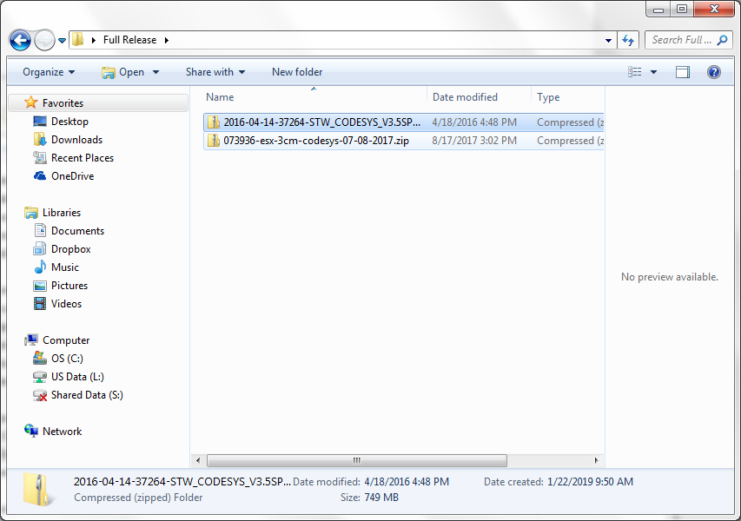

There will be two folders, one for CD data and one for CD labels. Open the file for CD Data.

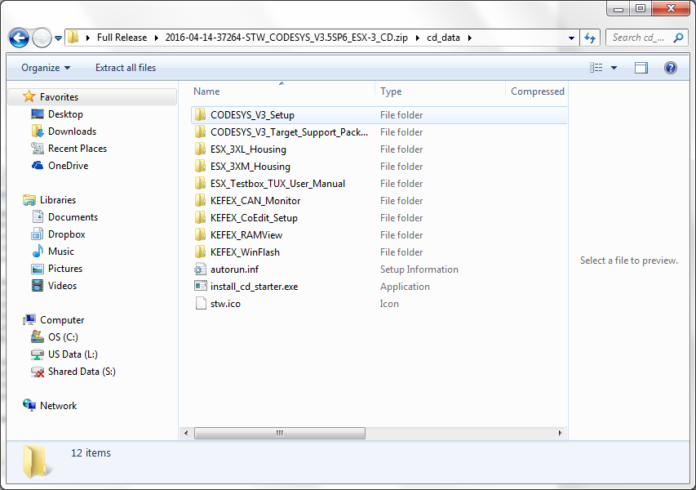
Double click on the install_cd_starter executable to start the installation process. This will bring up the following dialog box, which you will use to install the necessary applications.

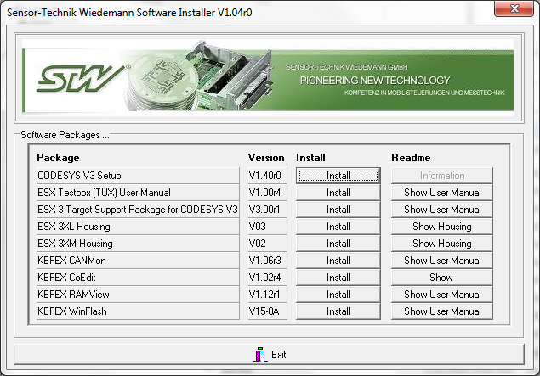
You will first install CoDeSys by clicking on Install for CODESYS V3 Setup.
You can then go through some typical install questions about destination locations. It is recommended that you use the default values.
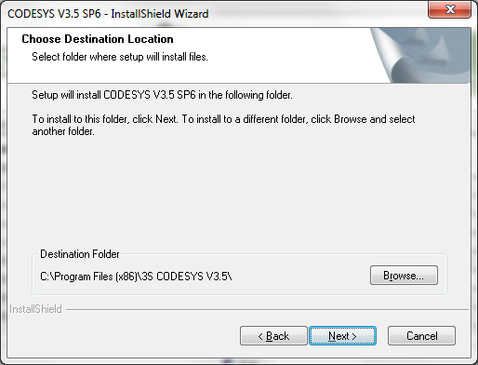
You will be asked which features you want to install. Again, go with the defaults. You will not need the OPC Server.
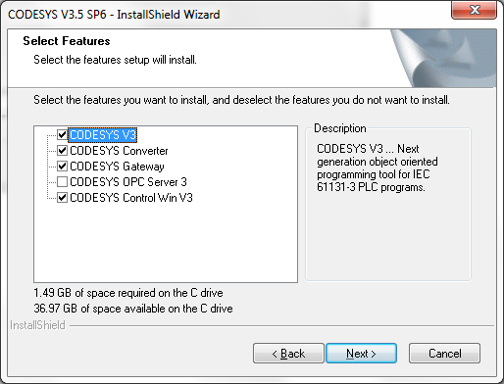
Choose the Program Folder that it recommends.
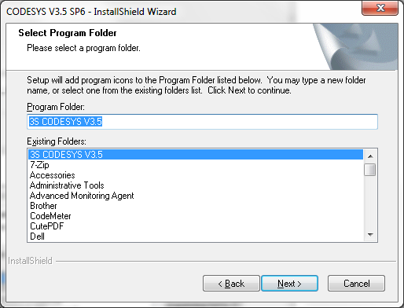
The installation of CoDeSys will take a long time and there will be a few dialog boxes that appear and need to be acknowledged. Sometimes these will be hidden by other applications so watch for them.

You may see a window like the one below. This is a license update and it can be closed without any action necessary.
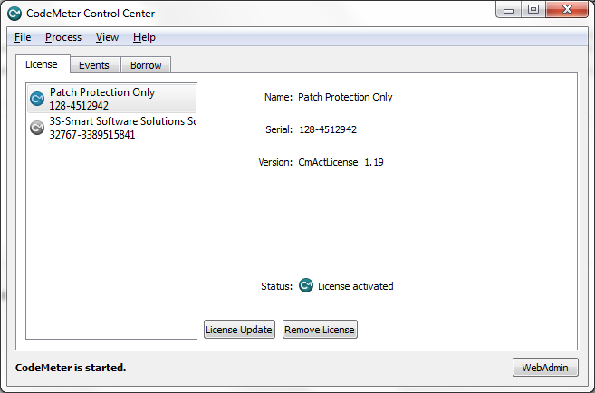
Once the CoDeSys installation is complete you will return to the list of applications that can be installed and start the installation of the Target Support Package. A dialog box will ask for the type of setup and you should accept the default ‘Typical setup’.

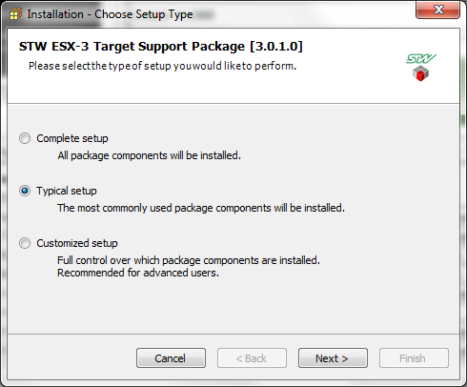

You will also see a list of components that will be installed or modified. Again, accept the default and click ‘Next’.
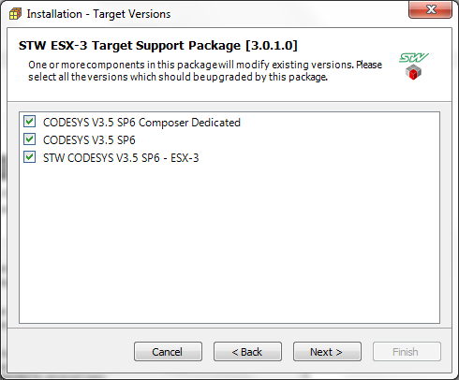

After the TSP has been installed you will want to install KEFEX Winflash. This will install the Winflash application that allows you to flash your controller with the CoDeSys hex file. It will also install several PEAK applications as mentioned earlier.
PEAK is a type of CAN interface and it is the best one to use to guarantee support from STW. Make the choice indicated in the graphic below to ensure that the PEAK applications and drivers are installed.

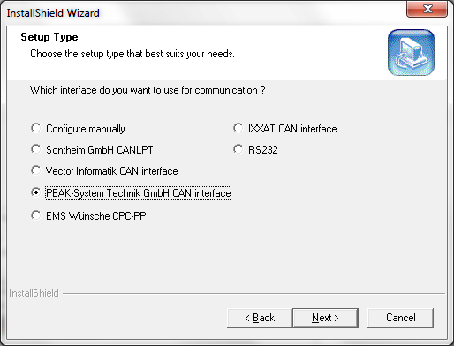

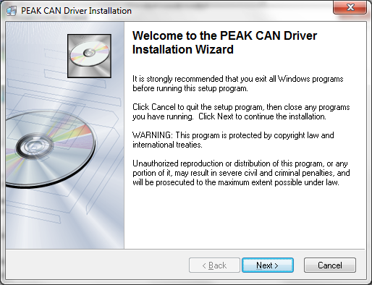

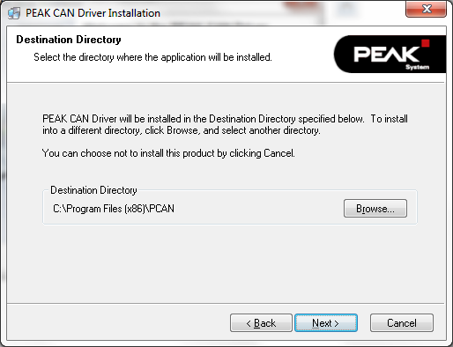

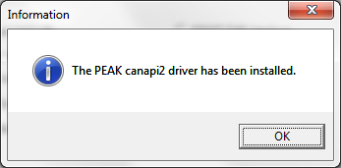

You will be using a USB connection so choose the PCAN USB for the setup type.

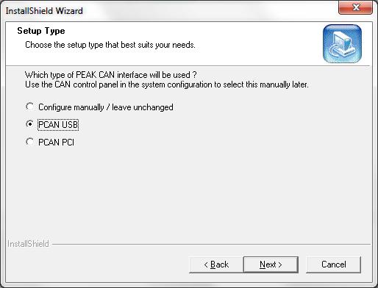

For the CAN interface to work correctly a CAN network will need to be established. STW generally names that network ‘TestNet’.
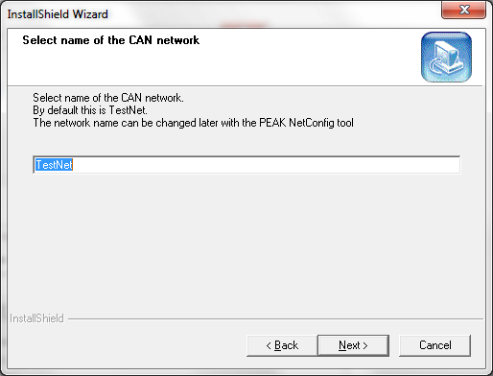

If there are problems with the CAN interface once you begin programming, then it is possible that the CAN driver was not properly installed. There is a separate document that describes how to troubleshoot and fix this problem.
There are three other KEFEX applications that you can be installed:
- KEFEX Coedit
- KEFEX RAMView
- KEFEX CANMon
KEFEX Coedit can be useful if you are using CANOpen on your network. Talk to your STW sales rep to discuss this. KEFEX RAMView can be helpful to manage the EEPROM in your controller for creating and saving permanent (non-volatile) variables such as setpoints, thresholds, etc. It can also be used for diagnostics, but CoDeSys offers its own very nice diagnostic capability via its Gateway login. Again, this can be discussed with your sales rep. KEFEX CANmon is rarely used, because viewing CAN traffic is generally done with the PEAK PCANView application.

Once the installation is complete you will have 3 new sections in your program list –
- one for 3S Codesys
- one for STW and one for
- PEAK or PCAN.

